GSOT

KPIs - LTV, Churn, Lapsed

Calculations:- Customer Lifetime Value over time ACROSS CUSTOMER SEGS, Churn Rate, ROI, Conversion rate, lapsed percentage,

LIFETIME Value = 1 / CHURN RATE * Average revenue per customer

CHURN RATE = CHURN CUSTOMERS / CUSTOMERS ARE BEGINNING OF PERIOD

* CHURN CUSTOMERS = CUSTOMERS AT BEGINNING OF PERIOD - CUSTOMERS AT END OF PERIOD
* TOTAL CUSTOMERS - LAPSED CUSTOMERS AT 2022

Count of customers total 2020

Count of customers total 2022

CONVERSION RATE - Number of purchases / number of interactions

LAPSED PERCENTAGE - number of interactions (from lapsed users) /number of lapsed users - overall visits from lapsed customers, site activity including guests over 3 years

Define and calculate (avg repeat) purchases for the below:- users table + extra column for below

USE CASE STATEMENT

* new customer - last 3 or 6 months of 2022 - CASE WHEN FIRST PURCH DATE BETWEEN SEPT & DEC 2022 - MAX DATE AND MAX DATE LESS 3 MONTHS???
* returning customer - within 6 months of previous purchase - CASE WHEN FIRST PURCH LESS MAX DATE - 6 ???
* lapsed customer - ordered >6 months of previous purchase & not ordered since
* re-activated customer - after 6 months of previous purchase

Nazmie’s code notes for above:-

SELECT user_crm_id, (latest_purchase_date - first_purchase_date) / 180 AS duration, transaction_count

CASE WHEN duration > 6 months AND transaction_count = 1 THEN lapsed,

WHEN duration > 6 months AND transaction_count = 2 THEN reactivated,

WHEN duration < 6 months AND transaction_count > 2 THEN returning

CASE WHEN duration = 0 AND latest_purchase_date BETWEEN ‘2022-09-30’ AND ‘2022-12-31’ AND transaction_count = 1 THEN new

ELSE END AS …?

FROM prism users

JOIN prism transactions

ON users.user_crm_id = transactions.user_crm_id

Returning = ordered > 1 in last 6 months

Lapsed = not ordered in last 6 months

New = has only ordered in last 6 months, no record of previous orders

Reactivated = more than 6 months between orders

SELECT user_crm_id, latest_purchase_date, first_purchase_date, transaction_count

CASE WHEN latest_purchase_date >= ‘2022-07-01’ AND first_purchase_date < ‘2022-07-01’ THEN returning,

WHEN latest_purchase_date < ‘2022-07-01’ THEN lapsed

WHEN first_purchase_date >= ‘2022-07-01’ THEN new

WHEN (latest_purchase_date - first_purchase_date) > 180 AND transaction_count = 2

THEN reactivated

ELSE END AS … ?

FROM prism users

JOIN prism transactions

ON users.user_crm_id = transactions.user_crm_id

Days between purchases

Lapsed cust - latest purch date < X days, no hard code for date periods

Concerns:- duplicate fields - user_crm_id (but multiple transaction_count) , first_purchase_date. Unique - latest_purchase_date - SO USE DISTINCT OR GROUP BY ??

ASSUMPTION - customer segments

New customer within last 90 days of dataset 30th Sept - 31st Dec ‘22

* **Lapsed customers visiting site - session id**

Looking at whole period then add slicer in pbi.

6 monthly/quarterly comparison over time period over 3 years

Analysis:-

Competitive Intelligence

The average company loses 20-40% of its customers every year <https://peoplepulse.com/resources/useful-articles/lapsed-customers/>

Limitations

* Definitions (lapsed customer, returning etc)

Possible recommendation

* Focused marketing to lapsed customers

ADDITIONAL NOTES:

1. It is likely that a large % of **new** customers churn instantly (recommendations)
2. Ensure any strategic objectives

MARKETING RESEARCH: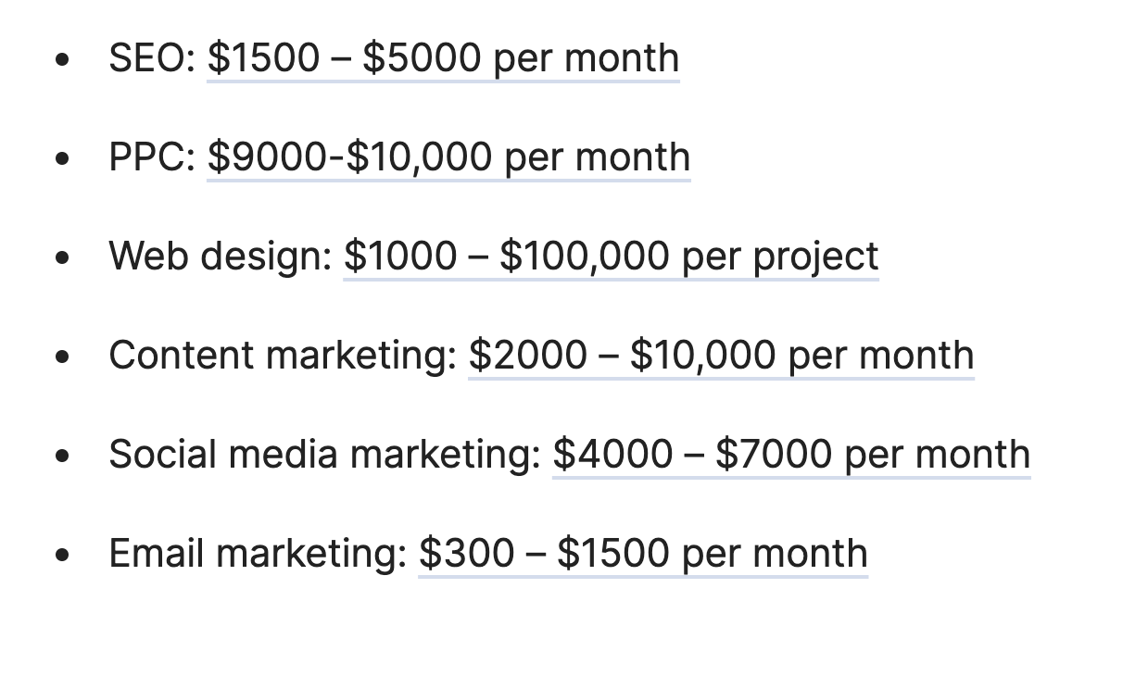

Average Cost Per Click (CPC) in AdWords across all industries is $2.32 on the search network and $0.58 on the display network. Search network average for ecommerce is $0.88 and the average for the display network is $0.29

PRESENTATION FIRST SLIDE FORMAT:

What we did, KPIs we used and recommendations we came up with

In Appendix, put a slicer for charts by segment and another slicer by time.

***If you believe that your efforts on winning back customers may not be worthwhile, think about this: 82-95% of unhappy customers will come back if impressed with your win back efforts and performed in a timely fashion. Furthermore, those customers will go on to refer, on average, five new customers.***

*Source: US Department of Consumer Affairs*

A 5% reduction in customer defection rate can increase profits by 25-125%, depending on the industry. Or put another way, a 2% increase in customer retention has the same effect as decreasing costs by 10%.

*Source: The Loyalty Effect, By Frederick F Reicheld, 1996, Harvard Business School Press. Chapter 2 – The Economics of Customer Loyalty*